1. <https://172.31.2.116/sundewuat/main/faculty-recruitment>
2. In this page there are four sections, please update the card images with relevant AI generated images with copyrights. - **Need image from Ritwik**
3. First section should be updated with the information from the link:

<https://www.iitk.ac.in/dofa/current-openings> - **Done - qa checked**

1. Following needs correction:

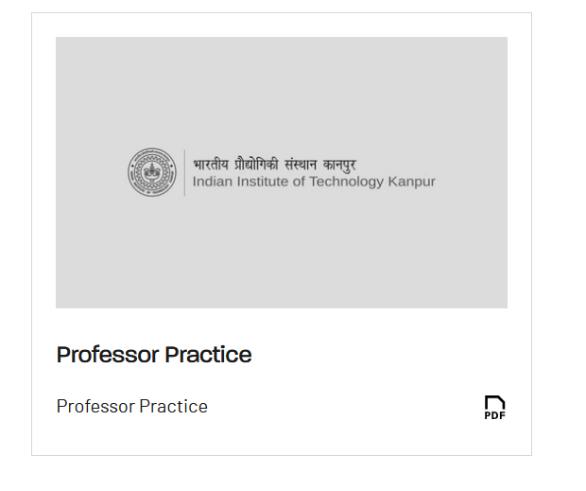

This should be Professor of Practice. Please correct it. – **Done – Qa checked**

1. <https://172.31.2.116/sundewuat/main/students>

Please remove OARS. – **Done – QA checked**

1. <https://172.31.2.116/sundewuat/main/registrar-office>

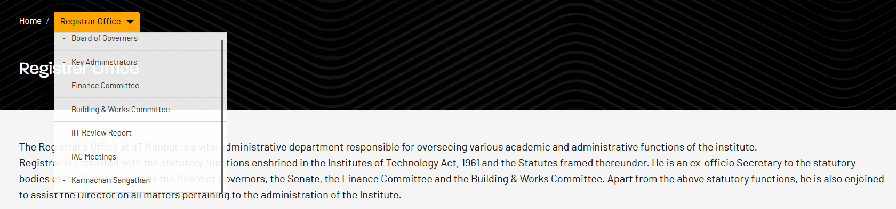



Please remove Karmachari Sanghatan from this menu. – **Done – QA checked**

1. Office orders from Home page leads to following: <https://172.31.2.116/sundewuat/main/office-orders>



It should be Finance & Accounts Office – **Done – QA checked**

1. <https://172.31.2.116/sundewuat/main/in-memoriam>

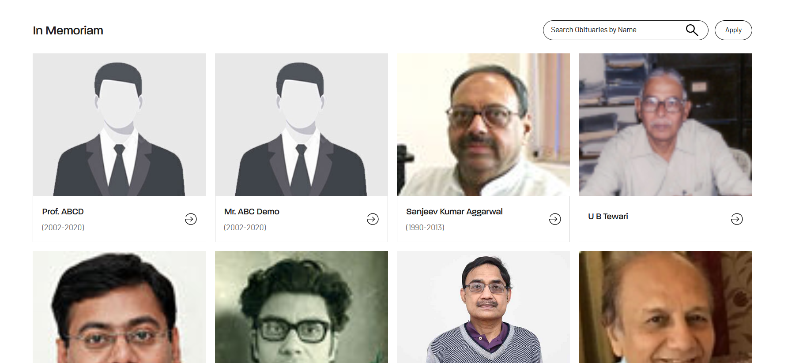

Please remove first two dummy Prof. ABCD and Mr. ABC Demo – **Done – QA checked**

This page should be in sink with the information in the live website link:

<https://www.iitk.ac.in/new/in-memoriam> (NOT DONE – QA checked)

**\*\* Also could not find the link leading to this in-memoriam page!!**

**In live website: NOT DONE**

**These links are given/don’t know where the same is shown in new website!**

**Where is the link to in-memoriam page in main website? – NOT DONE**

* 1. <https://172.31.2.116/sundewuat/main/staff>

Please link Research Management to DoRD Page : <https://www.iitk.ac.in/dord/> - **Done – QA checked**

1. <https://172.31.2.116/sundewuat/main/staff>

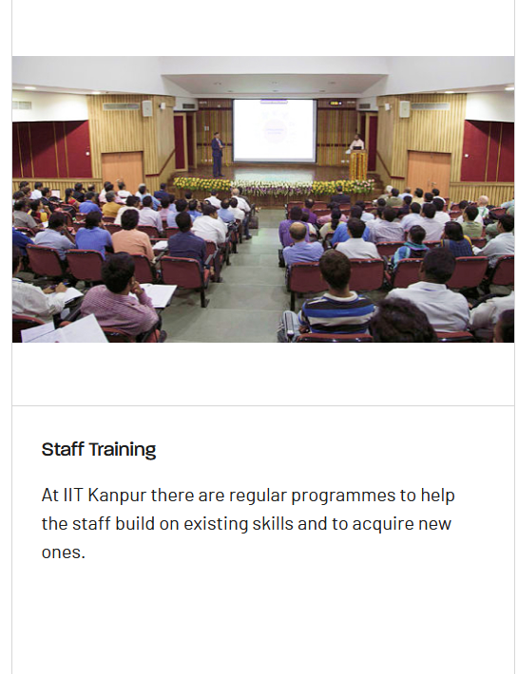

Please Make this section Title to **Staff Training Unit – Done – QA checked**

Link ‘Learn More’ to following link:

<https://iitk.ac.in/stu/> - **Done – QA checked**

1. **https://172.31.2.116/sundewuat/main/staff**



**Title here should be Deans. – Done – QA checked**

1. [**https://172.31.2.116/sundewuat/main/**](https://172.31.2.116/sundewuat/main/)



**It should be corrected to Internal Complaints Committee and International Relations – Done – QA checked**